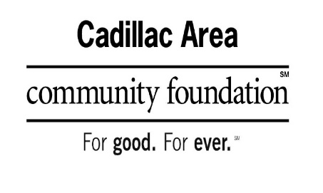
PAUL MCMULLEN TRACK & FIELD MEMORIAL
SCHOLARSHIP APPLICATION FORM
WEXFORD-MISSAUKEE ISD SCHOLARSHIPS Available
Paul McMullen Track & Field Memorial Scholarship is available to one male and one female graduate from the Wexford Missaukee ISD School District track and field performance results in the 1600 and/or 800 meter run. Grade point average, financial need, character, community service, and leadership will be taken into consideration. Paragraph capturing the spirit of Paul McMullen's, that nothing was impossible.

APPLICANT NAME: ________________________________________DATE OF BIRTH: ____________________________
ADDRESS: ___________________________________________________________________________________________________
TELEPHONE #:__________________________ EMAIL ADDRESS: _____ _______________________________________
Please check one: HIGH SCHOOL STUDENT: _____ COLLEGE STUDENT: _____ OTHER: _____

The following attachments are required to be submitted WITH your application.

*Page 1 of your FAFSA with your Expected Family Contribution (EFC), and your Student Aid Report (SAR).

* CURRENT HIGH SCHOOL STUDENT: Submit your most recent TRANSCRIPT, ACT and/or SAT WITH SCORE REPORTS.

* HOMESCHOOL STUDENT: Submit your most recent TRANSCRIPT, ACT, and/or SAT WITH SCORE REPORTS.

*A TWO PAGE, TYPED, DOUBLE SPACED, USING A 12-POINT FONT, PERSONAL ESSAY introducing yourself, WITHOUT YOUR NAME OR FAMILY MEMBERS NAMES, describe your course of study in college, your school choice, and career choice when you are finished with school. Also include how you may have grown and learned from personal or family challenges, i.e. health, financial, etc., that you consider pivotal to your maturing. Please close your essay describing where you see yourself in 5 years.

TYPE YOUR RESPONSES TO THE FOLLOWING QUESTIONS.
APPLICATIONS MUST BE TYPED TO BE CONSIDERED.
DO NOT INCLUDE YOUR NAME OR FAMILY NAME, IN YOUR EASSY
Academic Achievements
Please list special academic achievements such as membership in particular societies, advanced classes, awards, or any other type of academic recognition. (i.e. National Honor Society, Membership in Trade Associations, etc.) Limit your response to the last 2 years.
Leadership –List positions of Leadership that you have held. (i.e. Class officer, Sports Teams, Clubs, Church, Employment). Limit your response to the last 2 years.
Service – List examples that demonstrate your actions, including philanthropy through volunteerism and/or generosity, with or on behalf of others, without any direct financial or material compensation. Service contributions to scouts, school, clubs, committees, classmates, church, and community at large will all be considered. Limit your response to the last 2 years
Character – List examples of your behavior that demonstrate the qualities of respect, responsibility, trustworthiness, fairness, caring and citizenship. Please list employment, school activities, at least one extracurricular activity or sports participation that made and impact on your life, and special recognition you may have received. Limit your response to the last 2 years.

*LETTER FROM THE COACH - Please have your coach submit a letter via email to: cacf@cadillacfoundation.org, about team leadership and sportsmanship.

Please submit your completed scholarship application, with requested attachments, to:

Cadillac Area Community Foundation

201 North Mitchell Street, Suite 101

Cadillac, Michigan 49601

Application due no later than April 1 at 3 pm.

